**MUSIC PLAYER**

**Names:**

Pranav Gupta (2210990666): [pranav666.be22@chitkara.edu.in](mailto:pranav666.be22@chitkara.edu.in)

Rachit Walia (2210990695) : [rachit695.be22@chitkara.edu.in](mailto:rachit695.be22@chitkara.edu.in)

**Abstract**

* The Music Player is a device for playing and listening to digital audio files, which can be MP3 files or other audio files. The player was created in Python language. A GUI implementation of the application has been developed that is simple and easy to use.
* We all want to live a peaceful and calm life but for most people it becomes quite difficult to enjoy their time because of their hectic schedule.
* **Music** is a vital part of different moments of human life. It spreads [happiness](https://www.toppr.com/bytes/dalai-lama-spiritual-revolutionary/) and joy in a person’s life. Music is the soul of life and gives immense peace to us.
* The main objective of this project is to allow users to play MP3 and digital audio files. To be engaging for users, the application has to have a simple but beautiful user interface.
* The music player GUI project idea tries to emulate the physical music player. This program allows you to play songs, music and all music files on your desktop or laptop.

**Implementation**

* The data set was acquired by downloading the songs from the web and saving them in a particular folder.
* With the help of python libraries like Tkinter, OS, Pygame etc. the data was transformed in such a way that we could feed it to the machine.
* For interface we created a canvas using Tkinter.
* Added MP3 files using FnMatch.

**Tools/Technique used:** used libraries in python and visual studio code for coding.

**FLOWCHART**

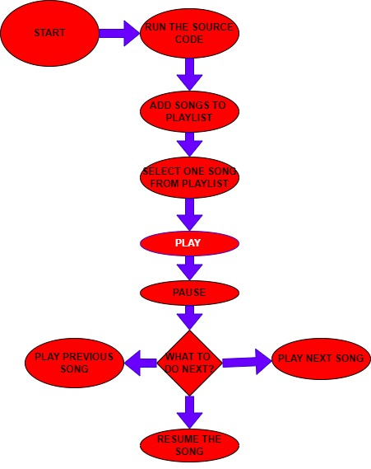

**Conclusion**

Now, we have our own music player and we can listen to songs when you work with data. Sometimes working with data could be very challenging and having your own mp3 music player is very helpful. In addition, I think that building an mp3 music player or other applications can really help you to know new Python modules and at the same time learn more about Python programming.

**Mentor Name:**  Dr. Gurpreet Singh